Bioinformatics

Title:

**domain**

Submitted by:

**Maryam zia**

Registration No:

**FA17-BSCS-055**

Submitted to:

**Dr farooq**

Date of submission:

**July 2, 2020**

**COMSATS University Islamabad**

Sahiwal Campus

**Greek key motif**

**Greek key motif**

**4 alpha helix**

**Greek key motif**

**8 alpha helix**

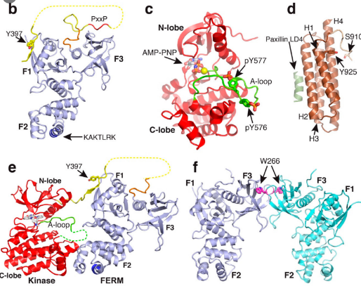



**8α-helix (Globin fold)**



**α -helix**

**Four Alpha helix bundle**

**(αααα)**



F1:4alpha helix

F2:alpha helix

F3 :Greek key motif

**Globin fold(8 α –helix)**



**8 alpha helix**

**8 alpha helix**